The Model Is the System:
Full-Stack Applications via MOSAIC -
a Model-driven, OPM-based System with Agentic Iterative Code generation

Advisor: Natali Levi
By: Stav Avraham, Omri Spitzer
Keywords: Generative, Artificial Intelligence, OPL, Text-To-Code, Software
Project Number: 26-1-R-7 (Capstone Project Phase B)
Repository: https://github.com/Stava06/Model-Based-Code-GenAI

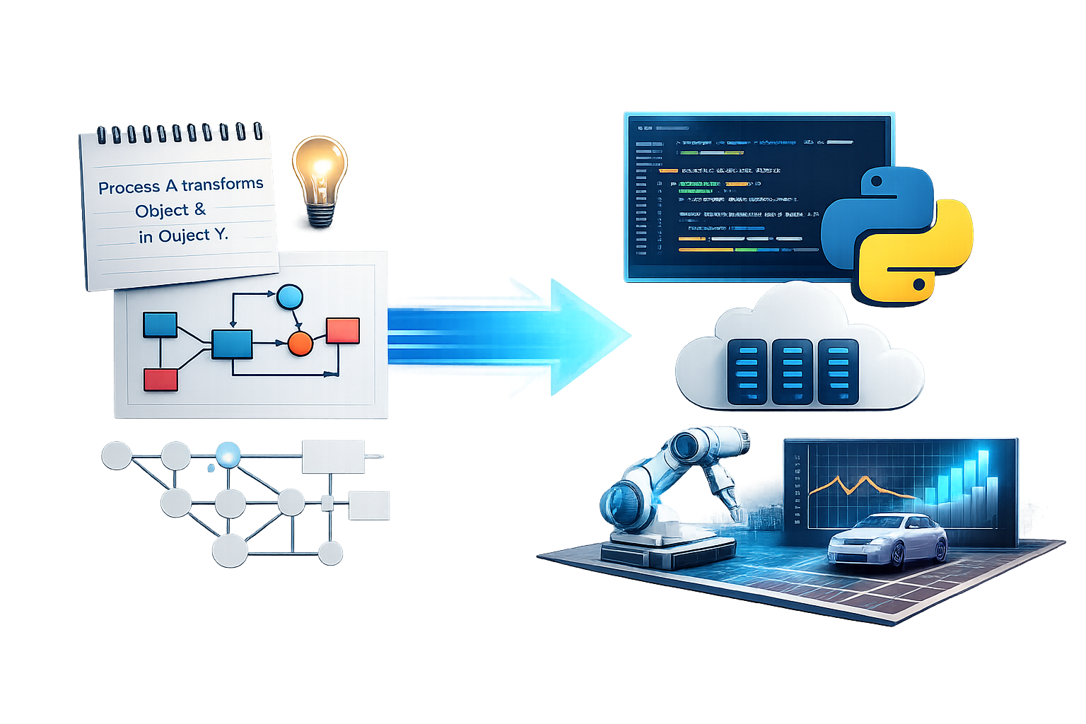

Table of Contents
- Abstract .............................................................................................................. 3
- Introduction ..................................................................................................... 3-4
- Literary Review ............................................................................................... 4-6
- Requirements .................................................................................................. 6-7
- Project Solution .............................................................................................. 7-8
- Deployment ........................................................................................................ 9
- Evaluation .................................................................................................... 10-11
- Discussion ........................................................................................................ 12
- Success Factors ……………………………………………………..…………..… 13
- Tools & Prompts ......................................................................................... 13-15
- Challenges ................................................................................................... 15-16
- Acceptance Tests ........................................................................................ 17-18
- References .................................................................................................. 18-20
- Appencies ......................................................................................................... 21

- Abstract
A central challenge in Model-Driven Engineering (MDE) is the growing divergence between conceptual system models and their corresponding implementations. While modeling languages such as OPM are widely used for system specification and design, the model-code gap tends to widen as development progresses: once implementation begins, the code evolves independently, and the model is gradually reduced to a static artifact that no longer reflects the living system.

We propose a fundamentally different approach: rather than treating the model as a specification that developers subsequently implement, we use an Object-Process Model (OPM) as the sole and persistent source from which a complete, runnable full-stack application is automatically generated, including backend logic, frontend interface, and software tests. By eliminating the manual translation step between model and code, ensuring that model and code remain consistent throughout the entire development process.

To realize this, we introduce MOSAIC - a Model-driven, OPM-based System with Agentic Iterative Code generation, built on Google's Agent Development Kit (ADK), in which three specialized roles: Supervisor, Generator, and Critic, collaborate iteratively to transform an OPL specification into a deployable software system. We present an initial working implementation of MOSAIC, demonstrated on a representative case study, and discuss directions for further refinement and the implications for MDE: if OPM can reliably drive full-stack generation, modeling shifts from a front-loaded specification activity to a continuously executable system definition

- Introduction
Developing well-engineered software begins with translating the client’s requirements into a well-structured architecture, designed by a software architecture. This initial phase is crucial for aligning the system to the client's demands. System diagrams, such as - UML [16], SysML [17], OPM [15] and more - aim to design the system’s structure and behavior. For our research, we chose OPM as our basis for the system structure.
Prof. Dov Dori mentioned in his article [14] that humans have dual-channel understanding mechanisms, image and textual representations. Based on those mechanisms, combining both representations enhances clear comprehension. OPM represents both the objects in a system and the processes that transform them, enabling the expression of behavioral flows between system entities. By capturing structure and behavior within a single model, OPM exposes the system’s architectural layers and the relationships among them. In this context, OPL serves as the derived textual counterpart of the OPM diagram, providing a clear and consistent natural language description of the same objects and processes.

Generative Artificial Intelligence [4] has become widely used, with many advantages. Clients increasingly attempt to create software by describing their needs to an AI tool and expecting it to generate a complete solution. These AI tools are capable of creating the code, but can often lead to system implementation problems.

Relying solely on free-text instructions has significant limitations. Natural language is ambivalent, and often lacks the level of detail required to fully define a system’s structure and behavior. Although GenAI tools can generate code, they may misinterpret requirements, overlook essential constraints, or fill in missing information with assumptions that do not match the client’s intent.

As a result, the produced software may appear functional but fail to represent the system’s intended architecture or logic. These inconsistencies make it difficult to rely on free-text-driven AI for building executable code that aligns with the client requirements.

RQ1: Does code generated by an AI agent pre-trained on OPL logic, is more consistent with client requirements, compared to code developed manually by human programmers?

RQ2: To what extent do the results generated by the AI agent meet the specified client requirements, while being executable?

In the following chapters, we intend to answer the questions beforehand. Chapter 2 shows our review of related solutions and their drawbacks. Chapter 3 explains our project's functional and non-functional requirements. In Chapter 4, we summarize our solution, while in Chapter 5, we explain the architecture. In Chapters 5 and 6 we explain the agents evaluation metrics and our project’s success factors. Chapter 7 explains the tools and prompts used to achieve the solution, and in Chapter 8 we show our challenges in the making of the agent. In the final Chapter we give references used for the Literature Review.

- Literary Review
Software systems went through a significant evolution over the past decades, growing from small, one-purpose programs into large, complex, and highly connected systems. Modern software development typically follows a multi-stage lifecycle that includes requirement definition, system design, implementation, testing, deployment, and long-term maintenance [1][2]. Therefore, each of these stages demands more time and resources, as to the size of the system programmed. In particular, the gap between meeting client requirements and executable implementations has widened, making it increasingly difficult to ensure correctness, consistency, and traceability throughout the development process [3].
In recent years, generative artificial intelligence (GenAI) [4], and in particular Large Language Models (LLMs), have become increasingly accessible for individual use [5]. Various GenAI agents have demonstrated the ability to process natural-language inputs, model systems, and generate software code [6], thereby enabling partial automation of the system design and implementation stages within the software lifecycle. As a result, employing such agents as instruments for code generation presents a significant advantage in software development, especially by accelerating development processes and reducing manual effort.

ChatGPT [7] is an example of a user-friendly generative AI system that provides high-level capabilities such as natural-language interaction and automated task execution [8]. A key strength of ChatGPT lies in its ability to translate textual user requests into executable code, enabling users to generate software directly from natural-language descriptions [8]. Similar capabilities have been demonstrated in applications using LLMs for software and systems engineering, where natural-language requirements are automatically transformed into models, test scenarios, and implementation code [9]. These approaches support faster prototyping and reduce the gap between high-level user intent and formal software artifacts, particularly in early development phases.
Despite these advantages, the generated responses are insufficient and are not reliable for software development tasks [8]. They may produce outputs that are syntactically correct yet semantically incorrect or misaligned with the original requirements [9]. This phenomenon, commonly referred to as hallucination, becomes particularly problematic in complex or safety-critical systems, where subtle semantic errors can lead to incorrect system behavior. Consequently, these limitations highlight the need for additional validation layers, such as model-based approaches (e.g., OPM), to enforce correctness, consistency, and traceability between requirements, models, and generated implementations.
AI-driven application builders like Base44 [10], allow users to describe an application in natural language and automatically generate full-stack solutions, including UI, backend, and data management. However, Base44 offers no formal guarantees of correctness, consistency, or traceability, relying on unstructured prompts and iterative refinement. While useful for rapid AI-assisted development, it does not support structured, validated transformation from formal requirements (e.g., OPL/OPM) to reliable software.
Another software solution is MAXIM via OPCloud [11][12]. To demonstrate its capabilities, the authors present a ‘Cockpit Display System’ [11], which serves as a realistic example of a complex system, composed of multiple interacting components and layers. When executed using OPCloud [12][13], the model shows the interaction between objects and processes. With inputs to object states, the client can validate system logic early in the design phase, reason about behavior, and demonstrate computability [11], without the assistance of a software architect.
Despite demonstrating executable models, MAXIM does not support automatic code generation [11][12]. Although architects can precisely capture client requirements and validate system behavior at the modeling level, the transition to implementation remains largely manual, which prolongs development and increases the likelihood of production errors [3].
These limitations motivate the adoption of a generative AI–based approach, which seeks to lower the expertise barrier, enabling the direct translation of natural-language requirements into software artifacts, and minimize the manual effort required to bridge the gap between design models and fully executable code. Due to economic constraints, the use of existing code generation agents was not considered in this research. Instead, we developed and fully implemented a dedicated agent specific to the objectives of this study.

- Requirements
Functional requirements:
- The system shall enable code generation.
- The system shall understand the OPL syntax.
- The system shall produce an executable code file.
- The system shall receive OPL text or html as input.
- The system shall evaluate the generated code.
- The system shall have a user interface.
- The system shall fetch and insert data into a database.

Non-functional requirements:
- The interface shall show the progress of the system.
- The interface shall receive one OPL at a time.
- Error messages shall be shown for invalid OPL inputs.
- Detailed logs shall be shown to help developers fix errors.
- The interface shall provide a clear and intuitive graphical user interface (GUI).
- The interface shall allow users to load and save OPL files locally.
- The system shall provide clear internal documentation for all major modules.
- The system shall separate the GUI code from the backend logic.
- The system shall use an AI agent.
- The system shall train the AI agent when in the building phase.

- Project Solution
Environment - User

Input : HTML / Text file
Output : ZIP file
Agent - Google ADK
LLM - Gemini
Roles - Instructions
Memory - MongoDB
Tools
Critic
Supervisor
Generator
Critic Tools
Supervisor Tools
Generator Tools

Figure 1: High-level architecture of our proposed MOSAIC agent, illustrating the overall workflow, internal components, and data flow.

Our solution, as shown in Figure 1 is a generative agent that uses Gemini’s LLM API to map OPL logic into executable code through a structured, multi-step workflow built with Google’s Agent Development Kit (ADK). The agent processes OPL input through defined roles, where each stage contributes to transforming the input into correct and executable code, with iterative refinement based on evaluation feedback. On initializing, the agent creates the OPL logic map using definitions retrieved from various sources, which later may be changed by the agent’s decision.

In the following pages, we define the agent’s roles as a set of structured instructions, illustrated by diagrams for clarity:
- The Supervisor acts as the central controller, selecting the appropriate role for each step based on the current objective. It is the only role that interacts with the user interface and operates under a defined iteration limit despite being able to invoke roles multiple times. On problem detection, the Supervisor generates a solution for it and may terminate the process early.
- The Generator reads the generated OPL logic map, and is responsible for producing syntactically valid code from a given OPL input and returning the result to the Supervisor, also operating under iteration constraints.
- The Critic evaluates the generated code according to predefined metrics, assessing its correctness and quality.
Generator - Instruction
Handoff to Supervisor
Get OPL Logic Map
Read OPL
Generate Code
Report a problem
Project name exist?
Set new project name
False
Success?
False
True
True
Save generated code
Supervisor - Instruction
Handoff to generator / critic
False
OPL Logic Map exists?
Initial Start?
True
Get Training files and re-generate OPL Logic Map
False
Supervisor First Step
Handoff to Generator
True
False
Reached max iterations?
Finish
True
Problem exists?
False
Finish
True
*Problem Workflow
Finish
Decide Next Role

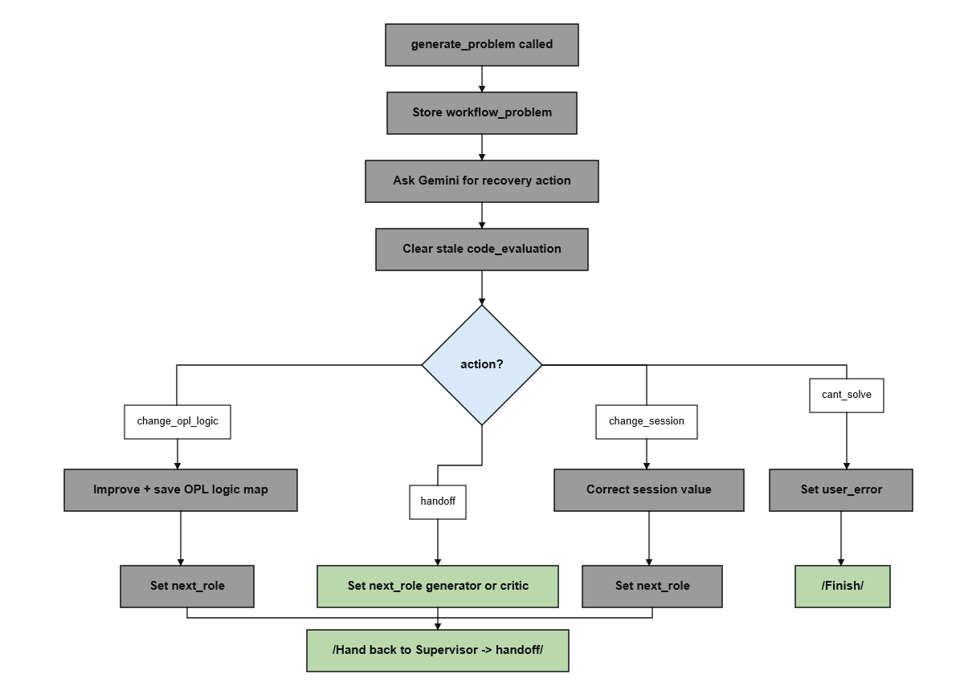
Problem Workflow

Critic - Instruction
Handoff to Supervisor
Get Evaluation Metrics
Generate Code Evaluation

Figure 2: Flow diagrams illustrating the decision-making and interaction between the Supervisor, Generator, Critic, and problem workflow components of the proposed MOSAIC agent.

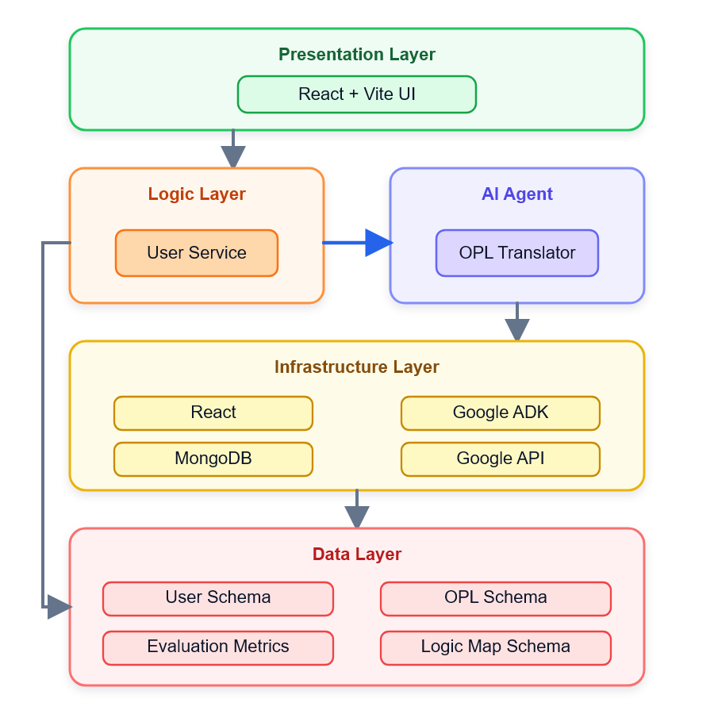
- Deployment

Figure 3 : Project Architecture - The project architecture integrates a multi-layer system where users interact through a presentation layer connected to logic, AI agent, and data layers supported by React, RL training, Gemini API, and MongoDB infrastructure.

Figure 3 presents the architecture of our project, which consists of four main layers:
- Presentation Layer – This layer represents the user interface of the web application. It is responsible for displaying data retrieved from the Logic Layer and providing users with interactive functionality.
- Logic Layer – This intermediate layer handles the core processing of the system. It manages communication between the user interface, the database, and the AI agent.
- Data Layer – This layer manages storage of system data for future retrieval and analysis. We chose MongoDB as our database due to its flexibility with unstructured data.
- Infrastructure Layer – This layer consists of external services and supporting technologies required for system operation.

- Evaluation
Table 1 presents the evaluation conclusions for MOSAIC. To evaluate MOSAIC, the OPL models were classified into small-scale (S) and large-scale (L) systems based on complexity factors, including the number of entities, processes, relationships, interactions, and overall model size [20]. The classification also considers the number of Software Development (SD) layers required for the generated application, where a higher number of layers indicates increased architectural complexity:

Table 1: Evaluation results of MOSAIC
No. | Metric | Description | Measurement | Result
1 | System Usability | How easy the MOSAIC system is to learn and operate | SUS questionnaire score (0–100) | (FTT - 40, ADHD - 32.5)
2 | Scalability | How the system performs with larger or more complex OPL models | Performance comparison by model size  (Success/Fail) | (S) - Success  (L) - Success
3 | Generation Time | Time required to generate a complete full-stack application | Time duration (seconds/minutes) | (S) - 2:47  (L) - 5:28
4 | Executability | Percentage of generated applications that run successfully without runtime errors and manual interference | Successful executions (%) | 10/12 (~83%)
5 | Requirement Coverage | Percentage of described requirements that are successfully implemented | Successful requirements (%) | 16/17 (~94%) requirements met (the agent doesn’t conduct training)

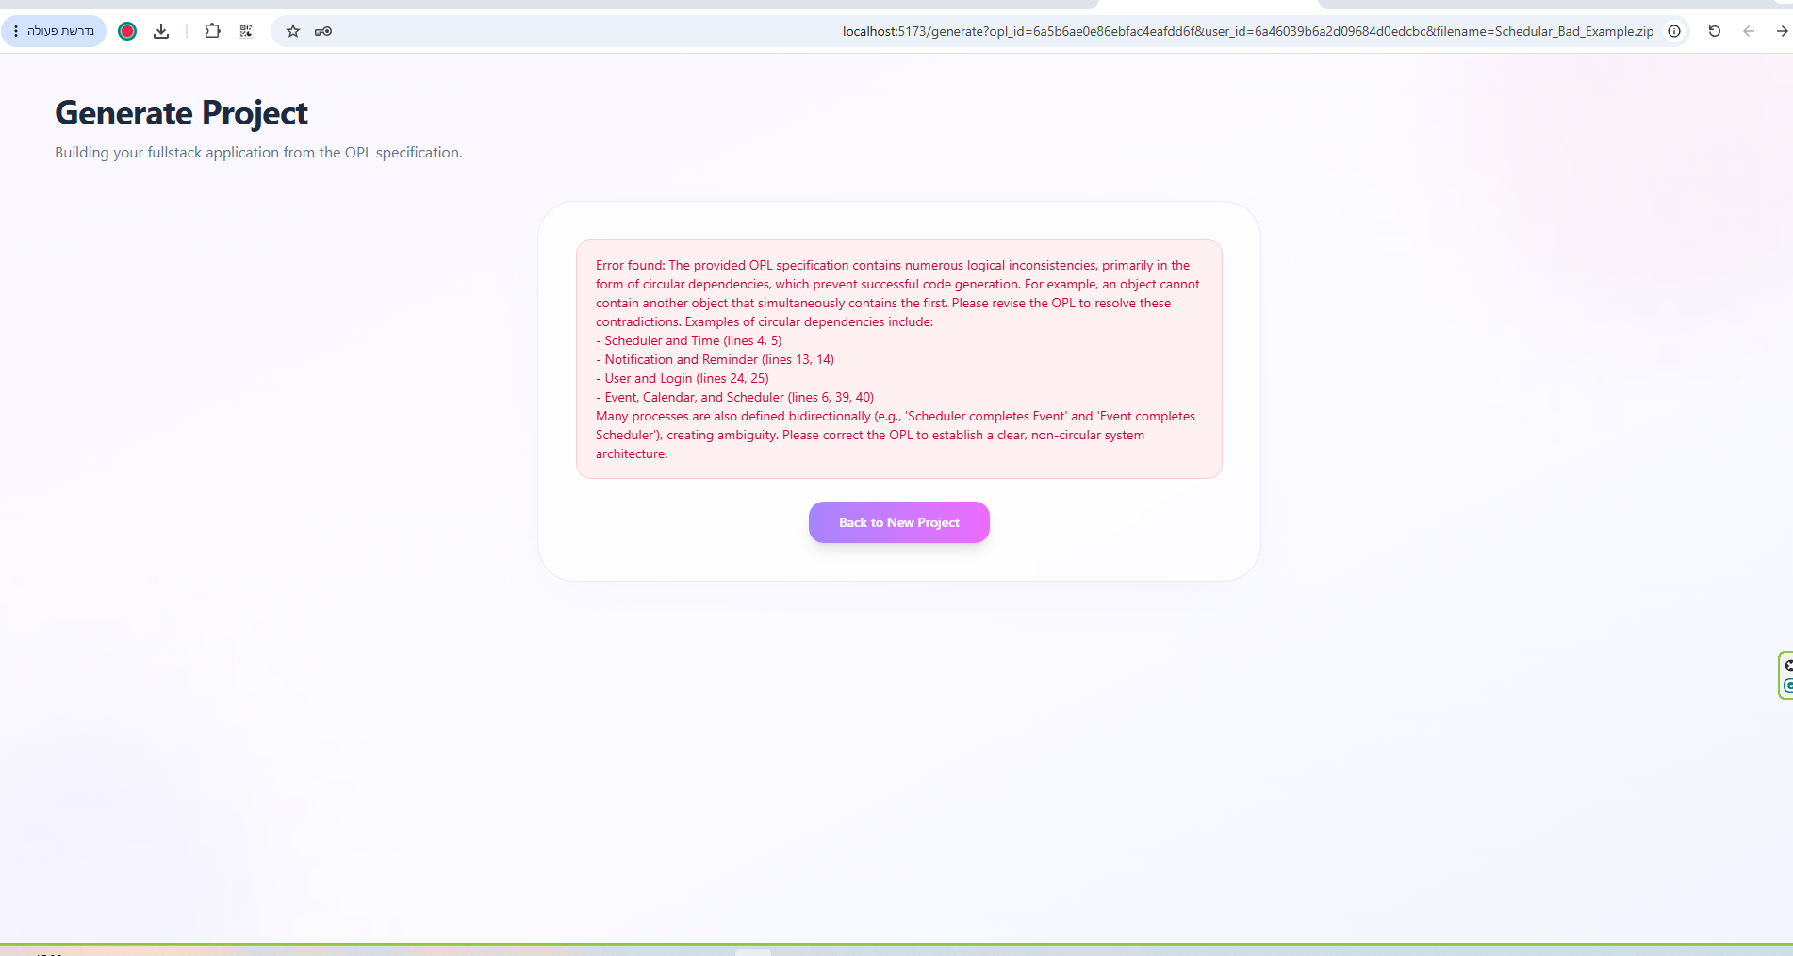
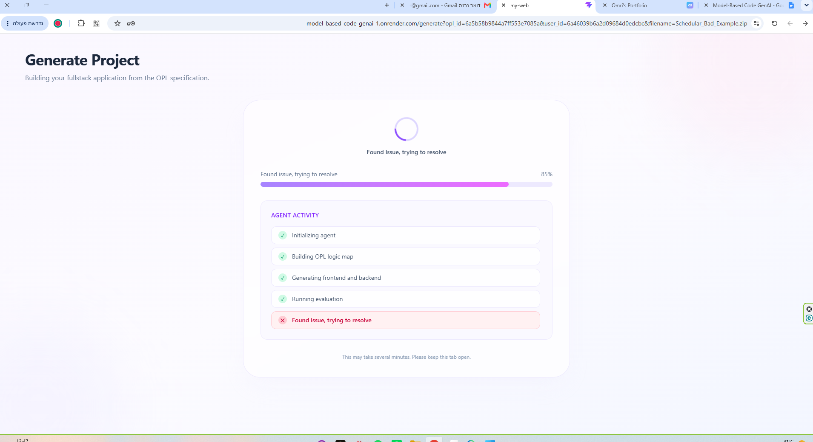

Figure 4 : MOSAIC validation output for the invalid Scheduler OPL model. The system detects circular dependencies and bidirectional process definitions, preventing code generation and providing corrective feedback.

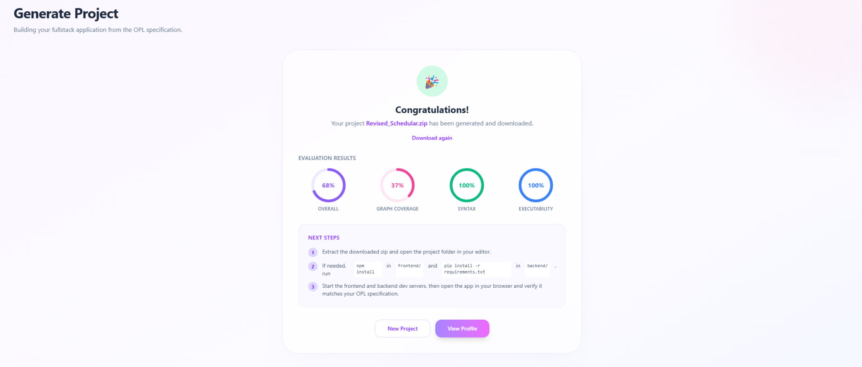

Figure 5 : Successful validation and code generation of the revised Schedular OPL model by MOSAIC.
Demonstration: To evaluate MOSAIC’s ability to identify and handle problematic OPL models, we intentionally provided it with the Scheduler OPL model containing inconsistencies and circular relationships [SCHEDULAR_OPL]. For example, the model contains circular relationships such as “Scheduler consists of Time” and “Time consists of Scheduler,” as well as conflicting relationships such as “Scheduler creates User” and “User deletes Scheduler.” Figure 4 presents the message generated by the agent, which identified the inconsistencies, rejected the problematic model, and provided corrective suggestions to the user.
We then applied the suggested changes to the OPL model, including removing circular relationships and correcting inconsistent object and process relationships. Figure 5 presents the agent’s final confirmation message for the revised Scheduler OPL model after the inconsistencies were resolved. The confirmation indicated that the revised model was successfully processed and that the website generation process was completed successfully. This demonstration shows MOSAIC’s ability to detect problematic OPL models, provide actionable corrective suggestions, and successfully generate an executable website after the identified inconsistencies are addressed.

- Discussion
To answer the research questions, we conducted an evaluation on two case studies by comparing applications generated by MOSAIC against their corresponding manually developed systems: FTT (ThrivePath) [18] and ADHD (BrainB) [19].

[RQ1]: The results indicate that MOSAIC effectively preserves requirements defined in the OPL model. For the FTT case study, MOSAIC achieved 135/166 (~81.3%) requirement coverage, compared to 41/166 (~24.7%) for the manually developed system. For the ADHD case study, both systems performed similarly, with MOSAIC achieving 40/59 (~67.8%) and the manual implementation 41/59 (~69.5%).

Overall, MOSAIC satisfied 16 of 17 (~94%) requirements presented to achieve. The only unmet requirement was machine-learning model training, which was not implemented due to time constraints of the research. Therefore, the achieved requirement coverage demonstrates that MOSAIC successfully implemented nearly all intended functionality despite excluding an entire feature category. These findings support RQ1, suggesting that OPL-guided code generation can produce software that is as consistent as, or more consistent than, manual development.

[RQ2]: MOSAIC successfully executed 10 of 12 (~83%) generated applications without manual intervention, demonstrating that most generated systems were functional. The framework also scaled successfully across multiple OPL models. Generation time increased with model complexity while remaining practical.
Usability scores were relatively low (40 for FTT and 32.5 for ADHD) compared to the manually developed systems (82 and 83.75, respectively). This is expected because MOSAIC is a research prototype focused on automated code generation rather than polished user interfaces.

The results demonstrate that integrating formal OPL models into the generation process enables MOSAIC to produce full-stack applications that closely follow client requirements while maintaining a high executability rate. Although improvements are needed in interface usability and generation robustness, the findings show that OPL-guided AI code generation is a promising approach for requirement-driven software development.

- Success Factors
To answer RQ1, we compare code generated by the OPL-pretrained AI agent with code manually written by human programmers (FTT (ThrivePath) [18] and ADHD (BrainB) [19]). Both outputs are evaluated using the same metric set. The results are then compared to determine which approach is more consistent with the specified client requirements.

To answer RQ2, we evaluate whether the generated code executes successfully and correctly implements the specified requirements. In addition, participants (students and individuals) will then evaluate the generated outputs using a questionnaire [SUS_Test] based on the System Usability Scale (SUS) to assess the usability and effectiveness of the system.

We aim to evaluate the agent's success based on achieving an overall score of above 65, while maintaining perfect execution and syntax evaluation scores (100). The graph coverage metric was found to be significantly more challenging to implement accurately due to the complexity of mapping generated code back to the original OPL specification and identifying all implemented entities and relationships. Therefore, the current graph-based evaluation remains an area requiring further refinement and improvement. Despite this limitation, a score above 65 is considered a reasonable target that indicates meaningful alignment between the generated solution and the OPL requirements, while ensuring that the generated application remains syntactically correct and fully executable.
- Tools & Prompts
The following list describes the technology tools used to construct MOSAIC:
- Google Agent Development Kit (ADK) – Used to build the core AI agent architecture. ADK orchestrates the three specialized roles (Supervisor, Generator, and Critic), manages the workflow between them, and coordinates the iterative code-generation process.
- Gemini API – Used as the Large Language Model (LLM) powering the AI agent. It generates the OPL logic map, creates the application code, evaluates the generated output, and provides solutions when issues are detected during the iterative generation process.
- React – Used to develop the web application's user interface. It allows users to upload OPL files, monitor the generation progress, view logs, and download the generated project through an interactive interface.
- MongoDB – Used as the project's database to store system information, generated projects, evaluation results, and other data required for future retrieval and analysis.
- FastAPI – Used to develop the backend of the MOSAIC web application. It manages communication between the React frontend, the AI agent, the Gemini API, and MongoDB, handling user requests and orchestrating the code-generation workflow.
- Flask – Used as the backend framework for the applications generated by MOSAIC. Each generated full-stack project includes a Flask API that provides routing, business logic, and communication between the generated frontend and its database.
- Git & GitHub – Used for version control and collaboration throughout the project. Git tracked code changes, while GitHub hosted the repository, enabling team collaboration, backup, and source code management.
- Node.js – Used as the runtime environment for the React frontend. It provides the development environment and package management (via npm) required to build, run, and deploy the user interface.
- OPCloud – Used to create and validate the Object-Process Models (OPM) and generate the corresponding OPL descriptions. These OPL specifications serve as the structured input that the AI agent transforms into a complete executable full-stack application.
Due to the considerable length of the prompts used in the system, they are not included in this document. Readers interested in the complete prompt implementations are encouraged to refer to the project's repository. The following list provides a brief description of each prompt used by the agent:
- _problem_resolution_prompt - determines the best recovery action when a workflow issue occurs. It can update the OPL logic map, rerun the Generator or Critic, correct session data, or return a user-facing error, producing a structured JSON response with the required action.
- _generate_opl_logic_map_prompt - generates an OPL logic map from the provided files by identifying the system's objects, processes, and relations. The output is returned as a structured JSON object following the required schema.
- generate_project_prompt - generates a complete, runnable full-stack application from the OPL specification and logic map. It creates a React frontend and Flask backend, ensuring all OPL objects and processes are implemented, connected through REST APIs, and returned as a structured JSON project with a code coverage graph.
- _gemini_reference_graph_prompt - generates a reference coverage graph from the OPL specification by extracting all objects, processes, states, and their relationships. The output follows a structured schema and serves as the reference model for evaluating code coverage.
- _generator_role - defines the Generator role workflow for creating the project code. It enforces the required tool sequence to load the OPL logic map, generate a domain-specific full-stack application, save the generated code, and hand control back to the Supervisor while ensuring the generated zip exists.

- _critic_role - defines the Critic role workflow for evaluating generated code against the OPL specification. It retrieves evaluation metrics, performs code evaluation using coverage and quality checks, stores the results, and hands control back to the Supervisor without modifying the generated project.
- supervisor_role - defines the Supervisor role workflow for orchestrating the OPL-to-code generation process. It manages role handoffs, OPL logic map creation, iteration control, problem resolution, and final delivery by coordinating the Generator and Critic roles.

- Challenges
The following bullet points summarize the key challenges addressed during the development of MOSAIC:
- Data availability - A potential challenge that could be is lack of sufficient datasets. Without enough high-quality data, the accuracy and reliability of the results may be significantly compromised, which could undermine the effectiveness of the solution.
- Technical expertise - Another limitation is our current level of technological knowledge. Implementing this solution may require specialized skills that we do not possess, making it difficult to develop and maintain the system properly.
- Technological environment - The project may also demand a technological infrastructure that is beyond our reach. For instance, running the system might require high-performance servers or cloud resources that are not accessible due to budget constraints or hardware limitations.
- Evaluation metrics - The defined evaluation metrics may tune for the worse, and lead to un-real results.
- Requirements Coverage - There is no clear deterministic way to measure how many OPL requirements were actually implemented in the generated code. Our solution was to build a graph from the OPL objects, relations, and processes, compare it with a similar graph built from the generated code, and use the result as an estimated coverage score.
How We Addressed the Challenges
For each challenge, we first tried to understand the root cause and choose the most suitable solution. Our main challenge was finding a reliable way to build and evaluate graph coverage.
Generated code can use different names, structures, or indirect implementations, which often cause lower coverage scores than expected. We explored comparing manually built graphs with agent-generated graphs, but due to time and technical constraints, we did not reach the optimal solution. This affected our ability to fully achieve the 80% overall score goal.
Insights Derived
Deep research and a strong understanding of the problem helped us the most throughout the project. However, we learned that research on AI agents should continue throughout the entire development process, since the field changes quickly. Within the available time and tools, we reached a result that answers our research goals and satisfies us.

- Acceptance Tests
Table 2 presents Acceptance Tests for MOSAIC:

Table 2: Overall application acceptance testing results and validation outcomes

No. | Test name | Expected Result | Actual Result
✅ 1 | Full-Stack Code Generation | Generate a complete Flask backend, React frontend, and project structure from an OPL model | The system generated all required project components successfully with no missing files
✅ 2 | Executable Generated Application | Build and launch the generated application successfully with core functionality operational | The generated application executed successfully after project build
✅ 3 | Requirement Coverage Evaluation | Generate a requirement coverage report and coverage score for the generated solution | The Critic generates an experimental graph coverage score to evaluate the generated graph, although the score is not fully reliable
✅ 4 | End-to-End Generation Workflow | Execute the complete Supervisor–Generator–Critic workflow without missing stages | Strict workflow instructions are implemented to ensure a smooth execution. Although occasional stage skips may occur due to the LLM, the workflow detects and repairs them automatically
✅ 5 | OPL Logic Map Generation | Generate and iteratively refine a logic map for code generation from the uploaded OPL model | The logic map was generated successfully and the Supervisor role refines it when the evaluation score is insufficient
✅ 6 | Login Validity and Edge Cases | Authenticate a registered user successfully, and reject missing credentials, wrong password, and unregistered email with the correct error flags | Valid login returns the fixture user; missing/empty fields return 400, and wrong password / unregistered email return 401 with the expected field flags
✅ 7 | Null / Empty OPL Text Rejection | Reject save requests when OPL text is null, empty, whitespace-only, or missing | All invalid OPL save payloads return HTTP 400 with an OPL-related error message
✅ 8 | Register Incomplete Payloads | Reject registration when name, email, or password is missing or empty | Incomplete registration payloads return HTTP 400 with the corresponding required-field flags
✅ 9 | Get User by Email | Resolve a known user by email, and return 404 for an unknown email | Fixture user is retrieved successfully; unknown email returns HTTP 404
✅ 10 | Save Valid OPL and Unknown Evaluation | Persist a non-empty OPL and allow retrieval; return 404 for an unknown evaluation id | Valid OPL saves and is readable for the owning user; unknown evaluation lookup returns HTTP 404
** All tests were conducted within the tests/test_acceptance.py file. For instructions regarding test execution, please refer to the “Maintenance Guide” section located in the Appendices.
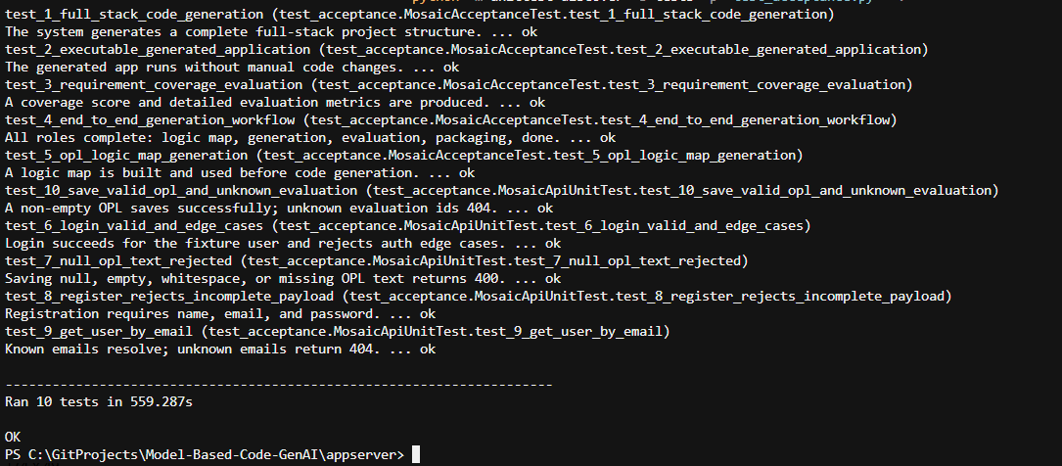

Figure 6 : Terminal output showing the successful execution of acceptance tests, with all 5 tests completed and passing.

- References

[1] Kute, S. S., & Thorat, S. D. (2014). A review on various software development life cycle (SDLC) models. International Journal of Research in Computer and Communication Technology, 3(7), 776–781.

[2] Hossain, M. I. (2023). Software development life cycle (SDLC) methodologies for information systems project management. International Journal For Multidisciplinary Research, 5(5). https://doi.org/10.36948/ijfmr.2023.v05i05.6223

[3] Bjarnason, E., Runeson, P., Borg, M., Unterkalmsteiner, M., Engström, E., Regnell, B., Sabaliauskaite, G., Loconsole, A., Gorschek, T., & Feldt, R. (2023). Challenges and practices in aligning requirements with verification and validation: A case study of six companies. arXiv. https://doi.org/10.48550/arXiv.2307.12489

[4] Zhijun Zhang, Jian Zhang, Xiaodong Zhang, Weijian Mai (2025). A comprehensive overview of Generative AI (GAI): Technologies, applications, and challenges. Neurocomputing, Volume 632, 2025, 129645, ISSN 0925-2312. https://doi.org/10.1016/j.neucom.2025.129645

[5] Chatterji, A., Cunningham, T., Deming, D. J., Hitzig, Z., Ong, C., Yan Shan, C., & Wadman, K. (2025). How people use ChatGPT (NBER Working Paper No. 34255). Cambridge, MA: National Bureau of Economic Research.

[6] Calegario, F., Burégio, V., Erivaldo, F., Andrade, D. M. C., Felix, K., Barbosa, N., Lucena, P. L. S., & França, C. (2023). Exploring the intersection of generative AI and software development [White paper]. arXiv. https://doi.org/10.48550/arXiv.2312.14262

[7] OpenAI. (n.d.). ChatGPT. https://chatgpt.com/

[8] Rice, S., Winter, S. R., & Rice, C. (2023). The advantages and limitations of using ChatGPT to enhance technological research. SSRN Electronic Journal. https://doi.org/10.2139/ssrn.4416080

[9] Jin, H., Huang, L., Cai, H., Yan, J., Li, B., & Chen, H. (2024). From LLMs to LLM-based agents for software engineering: A survey of current, challenges and future. arXiv. https://doi.org/10.48550/arXiv.2408.02479
[10] Wix. (n.d). Base44, https://base44.com/

[11] Levi-Soskin, N., Marwedel, S., Jbara, A., & Dori, D. (2024). Enhancing conceptual models with computational capabilities: A methodical approach to executable integrative modeling. Systems Engineering, 27, 759–770. https://doi.org/10.1002/sys.21750

[12] Dori, D., Kohen, H., Jbara, A., Wengrowicz, N., Lavi, R., Levi-Soskin, N., Bernstein, K., & Shani, U. (2020). OPCloud: An OPM integrated conceptual-executable modeling environment for industry 4.0. In Systems Engineering in the Fourth Industrial Revolution: Big Data, Novel Technologies, and Modern Systems Engineering (pp. 243–271). Wiley. https://doi.org/10.1002/9781119513957.ch11

[13] OPCloud. (n.d.). OPCloud. https://www.opcloud.tech/

[14] Dori, D. (2008). Words from pictures for dual-channel processing. COMMUNICATIONS OF THE ACM. https://dovdori.technion.ac.il/wp-content/uploads/2022/02/WordsFromPicturesForDualChannelProcessing.pdf
[15] Dori, D. (2002). Object-Process Methodology: A holistic systems paradigm. Springer. https://doi.org/10.1007/978-3-642-56209-9
[16] Object Management Group. (n.d.). Unified Modeling Language (UML). https://www.uml.org/
[17] Balmelli, L. (2007). An overview of the systems modeling language for products and systems development. Journal of Object Technology, 6(6), 149–177. https://doi.org/10.5381/jot.2007.6.6.a5
[18] Levi-Soskin, N., Sharoni, K., & Halifa, A. (2026). ThrivePath: Overcoming FTT Through Innovation (Project Code 25-1-D-17) [Undergraduate capstone project]. Braude Academic College of Engineering.
https://github.com/t5avish/ThrivePath
[19] Levi-Soskin, N., Knizhnik, S., & Adar, N. (2026). Enhancing classroom engagement: A multifaceted tool for managing attention difficulties [Undergraduate capstone project]. Software Engineering Department, Braude College.
https://github.com/nil-adar/BrainB

[20] Kinnunen, M. J. (2006). Complexity Measures for System Architecture Models (Master’s thesis, Massachusetts Institute of Technology, System Design and Management Program). Massachusetts Institute of Technology. http://hdl.handle.net/1721.1/35109
- Appencies
Website : https://model-based-code-genai-1.onrender.com
Repository : https://github.com/Stava06/Model-Based-Code-GenAI
User Guide : User Guide - MOSAIC
Maintenance Guide : Maintenance Guide - MOSAIC
SUS_Test : Code review questionnaire (John Brooke - 1986)
- I think that I would like to use this system frequently.
- I found the system unnecessarily complex.
- I thought the system was easy to use.
- I think that I would need the support of a technical person to be able to use this system.
- I found the various functions in this system were well integrated.
- I thought there was too much inconsistency in this system.
- I would imagine that most people would learn to use this system very quickly.
- I found the system very cumbersome to use.
- I felt very confident using the system.
- I needed to learn a lot of things before I could get going with this system.
Participants rate the following 10 statements on a 5-point Likert scale:
1 = Strongly disagree, 2 = Disagree, 3 = Neutral, 4 = Agree, 5 = Strongly agree
Scoring:
- Odd-numbered questions (1,3,5,7,9): score = response - 1
- Even-numbered questions (2,4,6,8,10): score = 5 - response
- After summing all question scores: final SUS = scores * 2.5
SCHEDULAR_OPL: (Inconsistencies are bolded, corresponding fixes are underlined)
- Scheduler serves Scheduler. - Scheduler serves User.
- Scheduler uses User.
- User consists of Scheduler. - Scheduler consists of User.
- Scheduler consists of Time.
- Time consists of Scheduler. - Time serves Scheduler.
- Scheduler consists of Event.
- Event consists of User.
- Event characterizes Scheduler.
- User characterizes Event.
- Event serves Calendar.
- Calendar uses Event.
- Calendar consists of Notification.
- Notification consists of Reminder.
- Reminder consists of Notification.
- Reminder serves Event.
- Event schedules Scheduler. - Scheduler schedules Event.
- Scheduler creates User. - Scheduler creates Event.
- User deletes Scheduler. - User deletes Event.
- Scheduler consumes Calendar.
- Calendar produces User. - Calendar produces Notification.
- Event stores Database.
- Database stores Scheduler. - Database stores Event.
- Scheduler stores Database. - Scheduler uses Database.
- User consists of Login.
- Login consists of User. - Login consists of Password.
- Authentication characterizes Password.
- Password authenticates Authentication.
- Scheduler consists of Authentication.
- Event logs into Scheduler.
- Login creates Password.
- Reminder reminds Notification. - Reminder reminds User.
- Notification schedules Reminder.
- Calendar updates Time.
- Time updates Calendar.
- Event changes User.
- User changes Event.
- Event consists of Description.
- Description consists of Event. - Description characterizes Event.
- Event contains Calendar.
- Calendar contains Scheduler.
- Scheduler completes Event.
- Event completes Scheduler.
- Reminder schedules User.
- User reminds Reminder.
- Scheduler displays Database.
- Database displays Scheduler.
- Notification consumes Event.
- Event produces Notification.
- Scheduler satisfies Database.
- Database serves Scheduler.

